## **Task 1**

**Test Case ID**

* **UI-NT.2**

**Scenario**

* **Purchase a Pet with no stock, above listed stock count and negative item quantity**

**Preconditions**

* Browser is open at <https://petstore.octoperf.com/actions/Catalog.action>
* Sign in with John Smith account, see A1. Account Details Appendix

**Test Steps**

1. Click “Enter the Store” and landed on Store page
2. Select Fish option on the furthest left-hand side
3. Click Fl-FW-02 link for Goldfish
4. Click EST-20 link for Adult Male Goldfish
5. View 5725 Goldfish in stock, click “Add to Cart” button
6. Taken to Shopping Cart page
7. Change Quantity to 999999 and press keyboard enter (see A2 Appendix)
8. Click “Proceed to Checkout” button
9. Land on Payment Form page, click on “Proceed to Checkout”, “Continue “, “Confirm” buttons in this order to land on order confirmation page (see A3 Appendix)
10. Click on “JPetStore” top left home button
11. Follow steps from 2 to 4
12. Adult Male Goldfish page shows correctly out of stock/Back Ordered, (see A4 Appendix)
13. Click “Add to Cart” button again
14. Change Quantity to 500, note “In Stock?” heading Displays false instead of true (see A5 Appendix)
15. Click on “Proceed to Checkout”, “Continue “, “Confirm” buttons in this order with new page to land on order confirmation page (see A6 Appendix)
16. Click on “JPetStore” top left home button
17. Follow steps from 2 to 4
18. Adult Male Goldfish page shows correctly out of stock/Back Ordered again.
19. Click “Add to Cart” button again
20. Change Quantity to -20, and press enter, shopping cart changed to empty
21. Click “My Account” button
22. Taken to Account Information Page, Click on “My Orders” button
23. Confirm Order Number is present, click into order number **147573 and 147575** and confirm details of 999999 and 500 goldfish orders respectively (see A7 Appendix)
24. Click “Sign Out” to land back on Store Page

**Expected Result**

* Users should not be able to add more than the available stock quantity to the cart or purchase beyond stock limits.
* Users should not be able to add a negative quantity to the cart.
* Pets that are out of stock should either:
  + Reject the “Add to Cart” or “Purchase” action.
  + Be listed as a pre-purchase option with an estimated restock date (ETA).

**Actual Result**

* Users can add more than the available stock quantity to the cart and complete the purchase.
* Adding a negative quantity is not allowed—instead, the cart resets to empty.
* Pets that are out of stock can still be added to the cart and purchased, with no indication of pre-purchase availability or restock ETA.

**Summary**

The negative test case failed, allowing users to purchase quantities exceeding available stock, including orders of 9999 units totaling $5,499,994. Additionally, purchases were permitted for items confirmed as out of stock, however the negative quantities did reset the cart back to empty. This presents a high-priority issue with significant business risks such as inventory management, financial tracking exploiting stock limit.

Recommend to enforce purchase limits based on real-time stock and restrict out-of-stock items or offer them as pre-purchase options with a restock ETA. Additionally, the "In Stock" status should be updated from a true/false boolean to something more user friendly.

**Appendix**

A1. Account Details

### **User Information**

|  |  |
| --- | --- |
| User ID: | John Smith |
| New password: | fake123 |
| Repeat password: | fake123 |

### **Account Information**

|  |  |
| --- | --- |
| First name: | John |
| Last name: | Smith |
| Email: | [Jsmith@gmail.com](mailto:Jsmith@gmail.com) |
| Phone: | 0430558808 |
| Address 1: | Level 8/207 Kent St |
| Address 2: |  |
| City: | Sydney |
| State: | NSW |
| Zip: | 2000 |
| Country: | Australia |

### **Profile Information**

|  |  |
| --- | --- |
| Language Preference: | English |
| Favourite Category: | FISH |
| Enable MyList | [x] |
| Enable MyBanner | [ ] |

A2. Shopping Cart 999999 Adult Male Goldfish

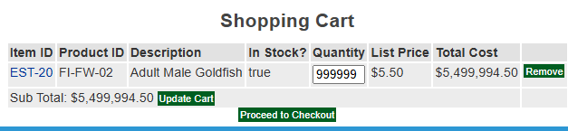

A3. Payment and Billing Address

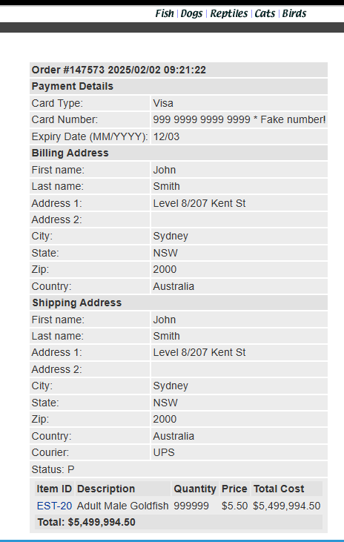

A4. Out of Stock Adult Male Goldfish

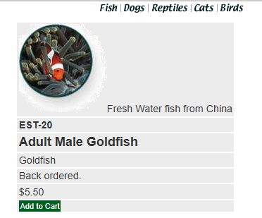

A5. Buying fish out of stock and display false

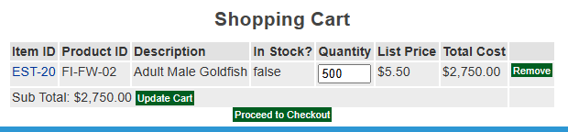

A6. Confirm buy 500 goldfish when not in stock

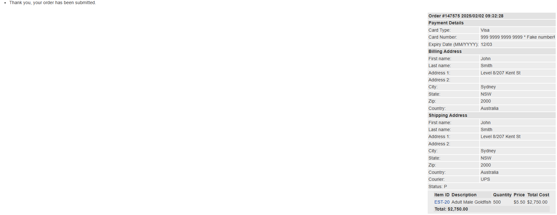

A7. Invoice number for Adult male Goldfish

